***How to control car-***

**For Bluetooth RC Controller App**

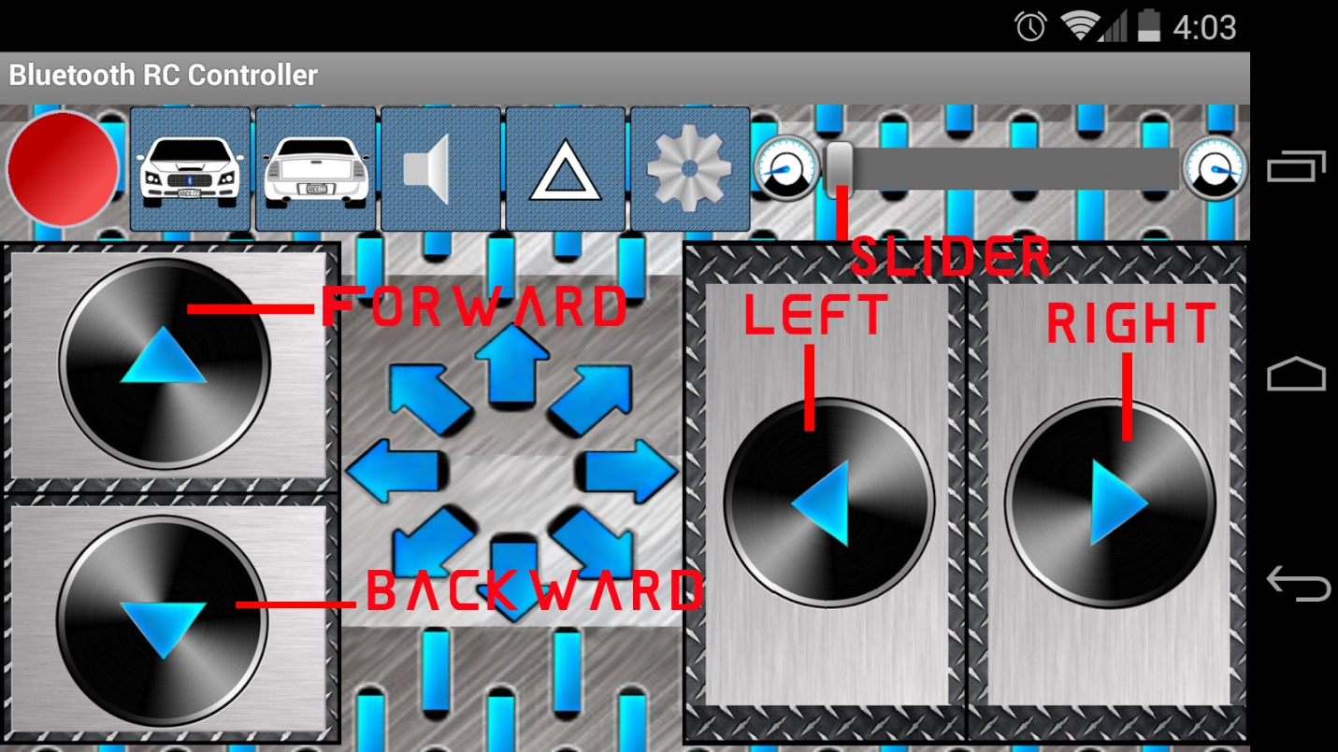

Hold **FORWARD** button to move forward.It will change pitch setpoint to **SLIDER** value.

Hold **BACKWARD** button to move backward

Hold **LEFT** button to turn left.On holding,it will continuously increment setpoint by **SLIDER** value.

Same case goes for **RIGHT** button.

Yaw can be minimum -180 to maximum +180.

By default,pitch & yaw setpoints are set to zero.

**For RC BLUE App**

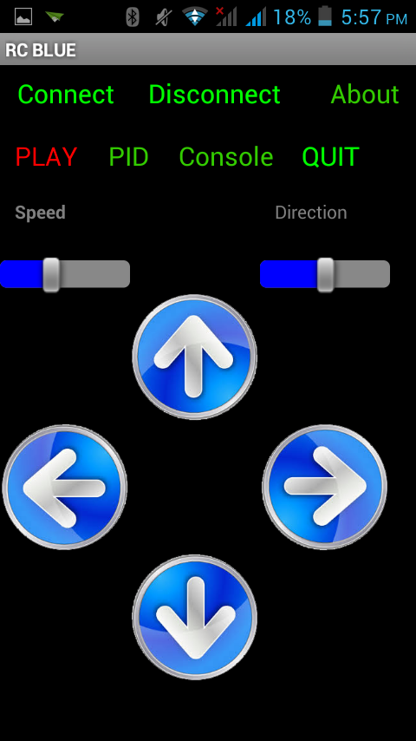

**FORWARD,BACKWARD,LEFT,RIGHT** are same. Only change is **Speed** slider will change pitch setpoint and **Direction** slider will change yaw setpoint.

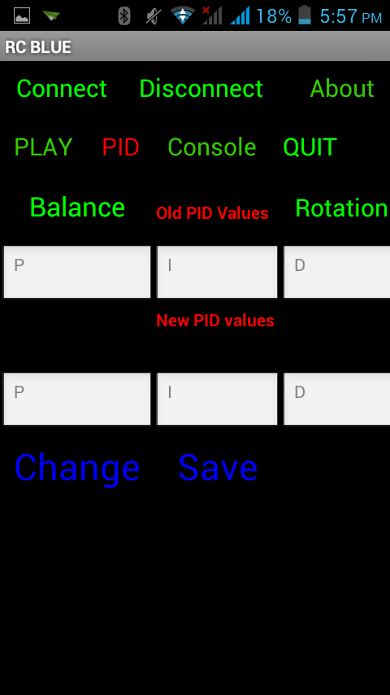

**BALANCE** will fetch balance PID values and **ROTATION** will fetch rotation PID values from EEPROM.

Enter PID values in text boxes.

**CHANGE** will temporarily change PID values.

**SAVE** will save PID values to EEPROM.

**NOTE**-*A MICROCONTROLLER has a limited number of EEPROM cycles*.